**MACHINE LEARNING MODEL DEPLOYMENT USING IBM CLOUD WATSON – CAD101**

ABSTRACT **:**

This project is all about carefully looking at Machine Learning Model Deployment Using **cloud IBM CLOUD WATSON**

IBM Cloud offers a variety of services and tools that can be used for Big Data analysis, including databases and analytics platforms.

OBJECTIVES **:**

**Model Integration and Accessibility:**

* Integrate the trained machine learning model into applications, websites, or other systems.
* To ensure that the model is accessible and usable by other components of the application or system, enabling predictions or inferences to be made based on new input data.

DESIGN AND THINKING **:**

**Select DB :** IBM Db2, IBM Cloudant, or IBM Databases for PostgreSQL , at <https://cloud.ibm.com/>

* Train and Save the Model
* Prepare the Model for Deployment
* Create a Watson Machine Learning Service Instance
* Upload the Model to Watson Machine Learning
* Deploy the Model
* Access the Deployed Model
* Test the Deployed Model
* Integrate the Model into Applications
* Monitor and Manage Deployed Models
* Scalability and Performance Optimization

IBM CLOUD ABSTRACT :

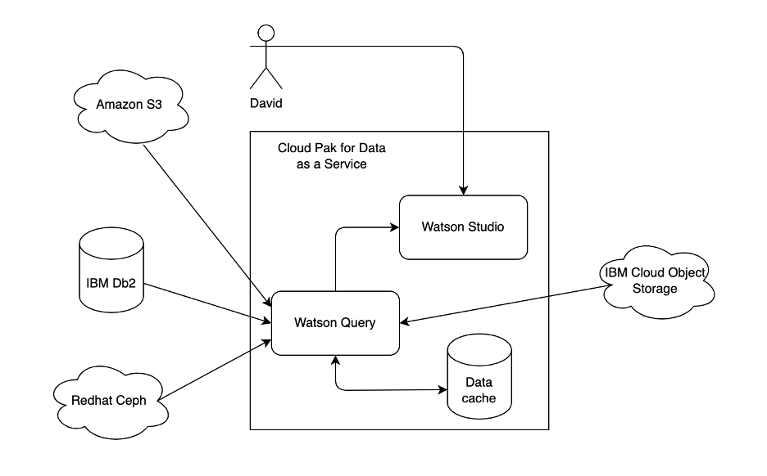

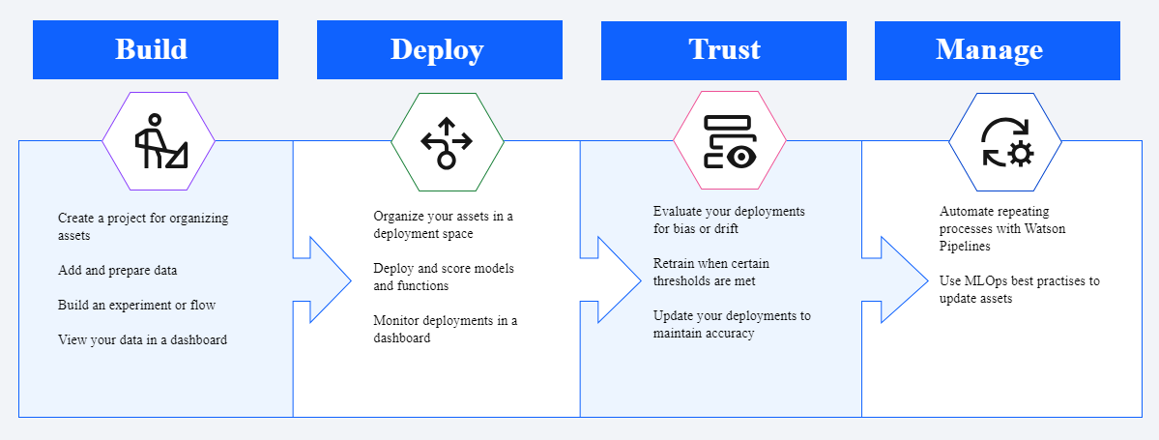

OUTLINE ABOUT THE PHASE-2

1. End-to-End ML Lifecycle Management: Watson Studio provides a unified platform for the entire ML lifecycle, including data preparation, model development, training, deployment, and monitoring.

2.Open Scale for Model Monitoring: IBM Watson Open Scale was integrated with Watson Studio to provide model monitoring and fairness monitoring capabilities. It allows you to track the performance of deployed models in real-time, detect and mitigate bias in AI models, and explain model predictions.

1. Model Deployment with Kubernetes: IBM Cloud Watson Studio supports deploying machine learning models using Kubernetes. Kubernetes provides a scalable and reliable container orchestration platform, making it easier to deploy and manage machine learning models in a production environment.

1. Integration with IBM Cloud Pak for Data: Watson Studio can be integrated with IBM Cloud Pak for Data, providing a comprehensive data and AI platform. This integration allows for seamless data integration, governance, and collaboration across teams working on data science and Machine learning objects.

OUTLINE ABOUT THE PHASE-3

IBM Cloud Watson Studio is a comprehensive platform for data science and machine learning that provides various tools and services to streamline the model development process.

1. **Define the Predictive Use Case:**

The first step is to define the problem you want to solve using machine learning. This could be anything from predicting customer churn to image classification. For this example, let's assume we want to build a model to predict customer churn for a telecommunications company.

1. **Select a Relevant Dataset:**

Next, you need to find and select a dataset that is relevant to your use case. You can use publicly available datasets or your own data if applicable. In this case, you might use a dataset containing customer information and historical churn data.

1. **Import the Dataset:**

In Watson Studio, you can import the dataset into your project. Watson Studio provides a user-friendly interface to upload and manage data. The dataset should be in a compatible format (e.g., CSV, Excel).

1. **Preprocess the Data:**

Data preprocessing is a crucial step. You may need to handle missing values, clean the data, and transform it to make it suitable for modelling. Watson Studio provides tools for data cleaning and transformation.

1. **Select Features:**

In this step, you choose which features (attributes) from the dataset will be used as input for your machine learning model. Feature selection can have a significant impact on model performance.

1. **Train the Machine Learning Model:**

Watson Studio offers a variety of machine learning algorithms and libraries. You can build and train your model using these tools. For customer churn prediction, you might use classification algorithms like logistic regression, decision trees, or a neural network.

**7.Deploy the Model:**

Once you have a satisfactory model, you can deploy it to make predictions on new data. Watson Studio provides deployment options, including APIs for real-time predictions.

OUTLINE IN PHASE-4

# 1. Prepare Model for Deployment

Before deploying your model, ensure that it is properly trained, tested, and ready for production use. You should have a saved and serialized version of your model.

# 2.Set Up IBM Cloud Watson Studio

* Access IBM Cloud Watson Studio and create a project that will host your deployed model.

# 3. Deploy Your Model in Watson Studio

* Inside your project, create a deployment space.
* Choose your model and deploy it to the deployment space. Watson Studio offers tools for deploying various types of models, including machine learning and deep learning model

# 4. Configure Your Deployment

* Define the runtime environment and resources for your deployed model. You can choose CPU or GPU configurations based on your model's requirements.
* Set up authentication and access controls to secure your deployed model.

# 5. Access the API Endpoint

Once your model is deployed, you will receive an API endpoint URL. This URL will allow you to send requests to your model and receive predictions.

# 6.Integrate the Model into Applications

Now that model is deployed and has an accessible API endpoint, you can start integrating it into your applications.

* Web Applications: If you are developing a web application, you can make

HTTP requests to the API endpoint using libraries like Axios, fetch, or Python's requests module. Parse the responses to display predictions or take further actions in your application.

* Mobile Applications: For mobile apps, you can use libraries or SDKs provided by the platform (e.g., iOS or Android) to send requests to the API endpoint and process the model's responses.

**CREATE A MODEL AND DEPLOY IN CLOUD IBM**

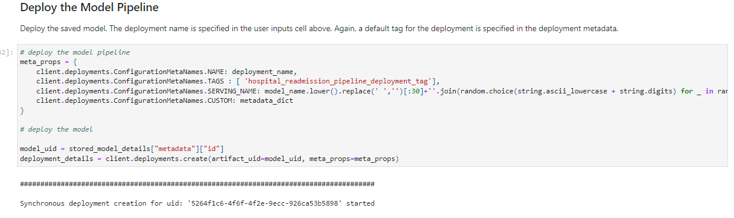

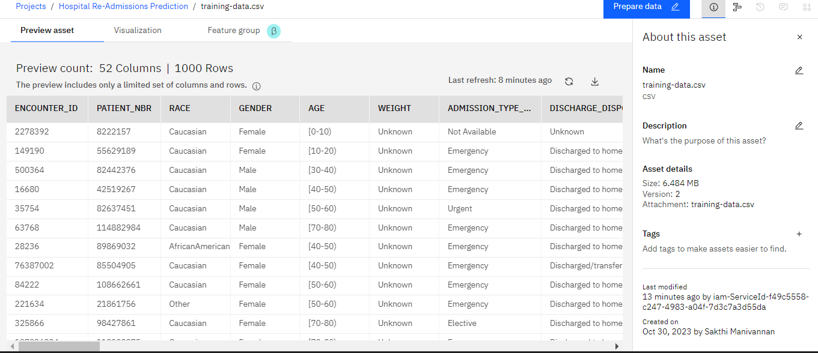

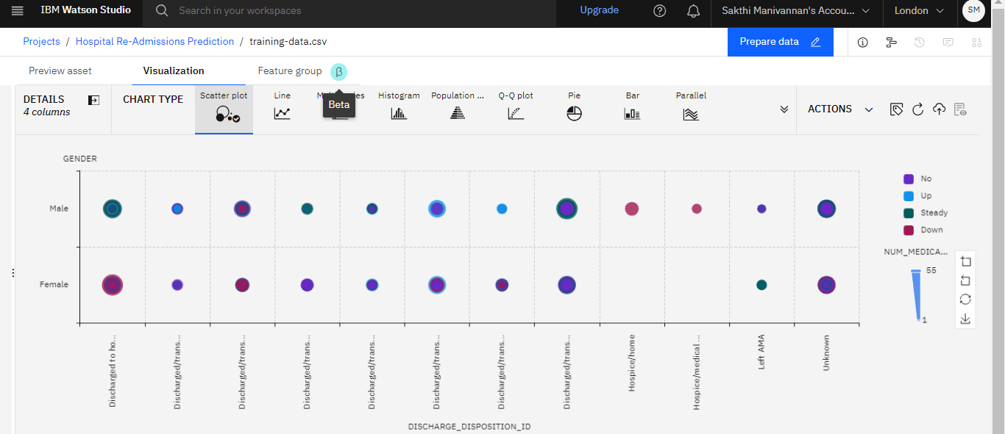

DEVELOPMENT PART

How the deployed model can be accessed and utilized for real-time predictions ?

Accessing and utilizing a deployed machine learning model for real-time predictions typically involves creating an API (Application Programming Interface) for the model and then making API calls from your applications or services. Here are the steps to access and utilize the deployed model for real-time predictions

1. **API Creation and Endpoint:**
   * After deployment, the platform will provide you with an API endpoint. This endpoint is the URL through which you can interact with your model. It will look something like https://xyz-model-endpoint-url.
2. **Authentication and Security:**
   * Implement authentication and security measures to protect your API. You may use API keys, tokens, or other methods to ensure that only authorized users can access your model.
3. **Request Format:**
   * Understand the format in which your model expects input data. This includes the data structure and any preprocessing requirements. For example, you might need to send JSON data, CSV files, or other formats.
4. **Real-Time Prediction Request:**
   * In your application or service, make HTTP requests to the model's API endpoint. You can use libraries like requests in Python to send POST requests with the input data.
5. **Input Data:**
   * Provide the necessary input data that you want to make predictions on. Ensure that the data is formatted according to the model's requirements.

CONCLUSION :

In this solution, we successfully designed and implemented a machine learning model deployment project using IBM Cloud Watson Studio. By following the problem definition,design thinking, development, and documentation phases, we trained a machine learning model, deployed it as a web service, and integrated it into applications. This empowers us to make real-time predictions and unlock the magic of data-driven insights, enabling informed decisions for various use cases.

By following these detailed steps, we’ll be able to successfully deploy a machine learning model using **IBM Watson Machine Learning**, making it accessible for predictions in our applications or systems.

PRESENTED BY TEAM:

M.Sakthi

B.Jayasudha

M.Swetha

C.Vinothini